PoG summary per learning point
- Describe the history of the discovery and research on galaxies in very broad terms
Charles Messier started cataloguing nebulae, later expanded by the New General Catalogue and the Index Catalogue.
Advances in studying galaxies were mostly governed by bigger and better telescopes. A key point in time was the development of photographic plates, so images didn’t have to be hand-drawn.
Herschel began classifying stars, assuming a uniform distribution and uniform absolute brightness. The former was because he was unaware of the principle of galaxies.
Kapteyn was the first to put a scale on the milky way by taking regions of the sky and watching how fast the stars moved. He thought the sun was close to the center, because the reddening effects were minimal. That’s because he missed the effects of Rayleigh scattering and instead figured it was due to absorption by interstellar dust.
Shapley estimated distances to globular clusters and found that they were spherically distributed, but not around the sun.
The great debate was about the size of the milky way and the nature of spiral nebulae. This was also about the existence of other galaxies like the milky way. Curtis assumed that they have such different sizes, so it is natural to assume that some are way further away. He also mentioned that M31 must be a milky-way sized galaxy. Shapley said that the milky way is so big itself, other “island universes” must be very far away. Based on Van Maanen’s incorrect measurements, he said that the rotations measured in these nebulae were too large to be that far away, thus disproving the existence of island universes. The most important takeaway is that dust is very important.
Hubble had a massive telescope, allowing him to see individual stars in M31, as well as observing variable cepheids. He puts these at a distance way outside the milky way, thus confirming the existence of island universes.
- Explain the magnitude system in different passbands
The magnitude system is used, because it makes use of relative measurements, which are more accurate than absolute measurements. The wavelength range a magnitude is measured in is called the passband.
Note that different passbands give information on different stellar populations. For example, young, hot stars are bluer, old and cool stars redder. Dust mostly absorbs blue light, making the result seem more red.
- Use the relations between absolute and apparent magnitude, flux, and distance to execute a calculation on one of these properties when given sufficient information on the others
Just look at the formula sheet man. Just know that HR goes from like 20 to -10 in absolute magnitude and that 5 magnitudes correspond to a factor 100 in both flux and luminosity.
- Classify galaxies in broad classes according to Hubble’s tuning fork
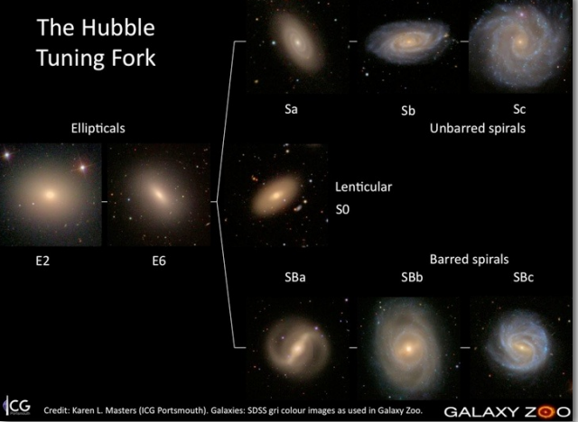
E0 means the semimajor axis is equal to the semiminor, E7 is the most elongated type possible. En, where n = 10[1 – b/a]. Sa and SBa have bore tightly wound arms, which goes down as you progress along the fork. The size of the galactic center also decreases as you progress.
Note that the morphology is usually radically different from the visual representation. Also note that the viewing angle is important. A spiral from the side might appear elliptical.
Of the moderately bright known galaxies, about 30% are elliptical and 70% are spiral. Approximately 3% are irregular.
- List the characteristics of these classes in terms of (for instance) typical mass and morphology
A perfect classification is: Complete, Homogeneous, Reproducable and aware of prejudices. Hubble’s tuning fork does not fit all these criteria. It can’t classify irregular galaxies and has trouble with spirals.
Ellipticals are often called the early type stars and the spirals and barred spirals are the late types. This is wrong, but as we know, astronomers don’t come back on mistakes. Spiral galaxies typically have way more young stars than elliptical galaxies.
Elliptical galaxies tend to be way brighter than spiral galaxies.
- Explain the concepts of surface brightness and isophotes
Surface brightness is defined as the amount of light per square arcsecond on the sky. There should hopefully be a formula for this if we need to use it. Surface brightness is independent of distance to the observer, except at very high redshift and like magnitudes, are always measured in a certain bandpass.
Isophotes are contours of constant surface brightness. These are independent of the distance to the observer, as any cosmological effects are (near) constant.
Ellipticals are often called the early type stars and the spirals and barred spirals are the late types. This is wrong, but as we know, astronomers don’t come back on mistakes. Spiral galaxies typically have way more young stars than elliptical galaxies.
- Describe the fundamental properties of stars in broad terms
For stars in equilibrium, the mass and chemical composition of a star uniquely determine its radius, luminosity and interior structure. This is known as the Vogt-Russell theorem. We know what all these things mean from PoS
- Explain how stellar populations look in a CMD, or a spectrum depending on their age and chemical composition
This is basically the Hertzsprung-Russell diagram
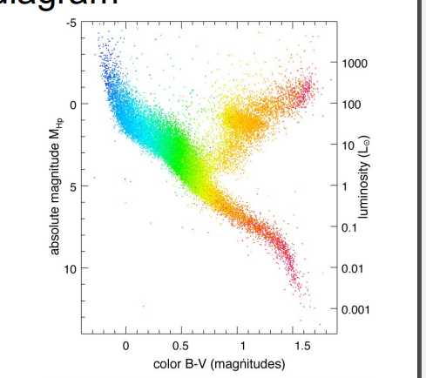
Dwarfs have stronger absorption lines compared to giants. Supergiants have even weaker absorption lines.
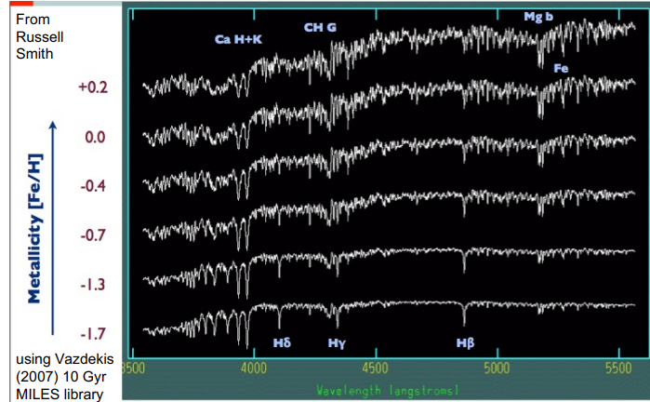
Absorption lines require metals in the atmosphere, or cold gas in the interstellar medium. This is not the case for the oldest populations. Old populations are most common in ellipticals and the bulges of spiral galaxies.
- Describe the luminosity function and (initial) mass function and make basic calculations using these relations
[TODO I am tired]
- Discuss the degeneracies and difficulties in assessing stellar populations
An important thing here is the Malmquist bias, stating that almost all samples taken have a certain magnitude limit, either unable to detect or easily saturating the measurement. We can detect bright stars way further out than faint stars.
You also have a lot of variables, like high metallicity, old populations or low mass, they all redden the spectrum, thus making it hard to disentangle all these things and find out what exactly is going on.
- Explain the distance ladder
At different distances from the observer, different methods of approximating the distance work best. At distances further out, one tends to only be able to find the distance by relating it to an other object, which distance itself is only known relative to some object, thus creating a sort of ladder where every step further out is dependent on the previous step.
- Describe the main steps on the distance ladder
- Parallax
Parallax uses the fact the earth moves -> apparent motion. By measuring the angle of the star on the sky at two different points in time, one can approximate the distance simply by using geometry, given the distance from the earth to the sun.
- Cepheids(Variable stars) and Supernovae type 1a(White dwarfs)17/06/2023 -> standard candles
This is a type of standard candles. The idea is to measure the brightness relative of some object of which you know the absolute magnitude or luminosity and using these relations to calculate the distance. A downside is you do need reliable measurements of nearby objects.
- Galaxies
By using things like the Tully-Fisher relation, one can relate luminosity to distance. We get this luminosity by measuring other things, like velocity in the disk. A problem is you need good measurements of the velocity, which at large distances can be quite difficult.
- Hubble Law
Hubble law relates the velocity to the distance using Hubble’s constant. However, this constant is not very well known, thus the distance measurements are quite uncertain. Note that also the peculiar velocity can play a role.
- Use parallaxes, standard candles and Hubble’s law to get distances
We have these formulas, just fill em in.
- Discuss their difficulties and uncertainties
These have been explained in point 12.
- Describe the different components of the Milky Way and discuss their properties
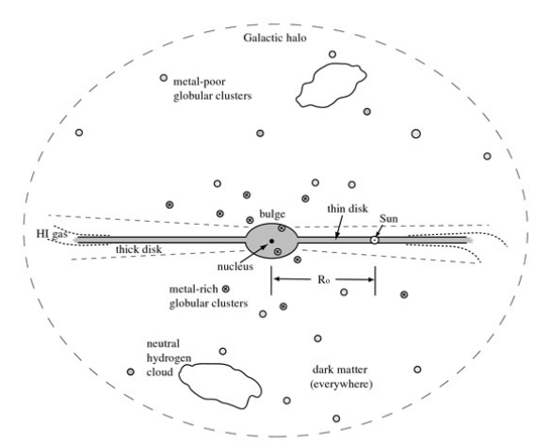
The thin disc is about 300 +- 50 pc wide. The radius is about 2-3 kpc and the mass is between 2.5 and 4.5 times 10^10 the mass of the sun.

The thick disc is about 900 +- 180 pc wide, has a radius of 2+-0.2 kpc and a mass between 3 and 9 times 10^9 solar masses.

In the bulge of the milky way, stars tend to be old and have high metallicity.
The milky way has a slight bar, but not enough to classify as a barred spiral.

The furthest star in the halo is over 200kpc away, while the disk is only 15kpc in diameter.
- Explain different coordinate systems and use them
Many coordinate systems work based on angles. Objects on the sky work with right ascension and declination. Adding the distance gives the spherical coordinate systems. Cartesian is used for objects in a 3d position and for objects in a rotating/flattened/axisymmetrical system, one can use cylindrical coordinates.
Galactic coordinate systems use either the sun or the center of the galaxy as reference point, and use the angles from there.
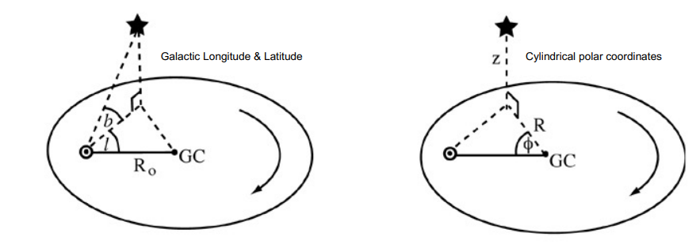
- Solve an analytical problem related to disk scale height and length
[TODO]
- Calculate velocity dispersions and discuss how they are related to the different components
[TODO]
- Explain how we measure rotation in the Galaxy and what the resulting evidence shows
Stars closer to the center complete their orbit quicker. This is however not how the spiral patterns originate. Stars do orbit in the same direction.
For calculation/derivations, see lecture slide 6
- Work through the derivation of the Oort’s constants (first part especially) and explain what they signify
See the derivation in lecture 6
- Explain the concept of the Local Standard of Rest, asymmetric drift, and the tangent point method
The sun doesn’t make a perfectly circular orbit around the galactic center. The LSR is defined as the mean rotational velocity of stars similar to the sun.
Asymmetric drift is the phenomenon where stars motions become more random with age, as they get heated up by encounters. This makes their motion different from other stars that had the same initial conditions
The tangent point method is based on the fact that V/R drops off with radius.
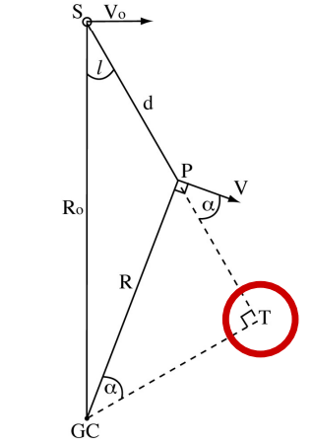
In this figure, the radial speed is largest at T for angles of l between 0 and 90 degrees. By looking at the emission lines in each of the lines of sight, we can determine the largest velocity in each of these lines.
- Describe the overall kinematical properties of the different Galactic components
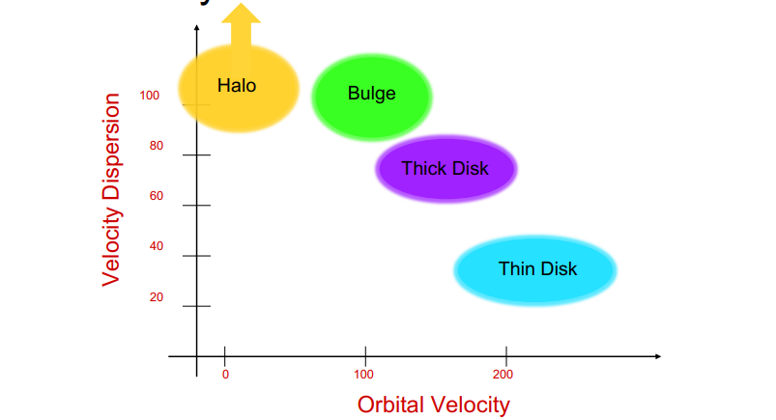
- Describe the fundamental principles behind the studies of gas properties in a galaxy in a very general way
The gas in the milky way is less than 10% of the stellar mass. The gas is vital for the creation of young stars and the creation of spiral arms. Gas is observed through emission lines or through a continuous spectrum. The latter is from diffuse ionized gas.
More ways to observe gas in lecture 7.
Important is mapping HI gas in a galaxy. This gives a good idea for interactions. In the milky way, the northern and southern halves are different when looking at the HI gas.
- Discuss how we can measure the properties of gas and what the caveats are
To get the distance, you can use the rotation curve, which you can obtain by the tangent point method for example.
The velocity can be obtained by the redshift.
The density could be measured by obtaining the temperature of a blackbody with the similar intensity and then plugging in a formula.
When looking at molecular gas instead of atomic, one can observe extra transitions and rotations around the center of mass. The most common molecule is H2, but this gas doesn’t radiate as it has no dipole moment. Molecular gas tends to be very cold.
- Discuss the various stages of gas in the Milky Way and their importance
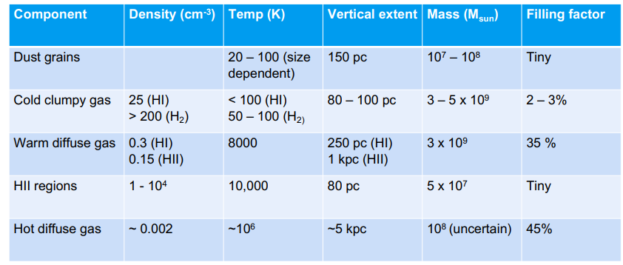
[TODO importance?]
- Define strong and weak stellar encounters, calculate their impact, and discuss their relevance in various systems
The gravitational potential of a galaxy is a sum of smooth averages over stars and narrow, deep wells at the positions of individual stars. The motion in a galaxy is almost entirely by the smooth component.
A strong encounter is when a trajectory changes significantly. A weak encounter is when there is only a slight perturbation. For the first one, this can be quantified as the change in potential energy is at least as large as the initial kinetic energy. The radius in which this tends to happen is about 1AU, while the nearest star to us is at 271000 AU away.
t_s is defined as the characteristic time scale between collisions. For the sun, this value is about 10^14, so older than the age of the universe.
- Explain the concepts of crossing time, relaxation time, and evaporation time and discuss them relative to each other
Relaxation time is the time it takes a star to lose its memory of its initial path. This losing is due to the many weak encounters it has. More rigid, the relaxation time is the time it takes for a star in a certain system to change its velocity by the same order due to weak encounters with a “sea” of stars.
[TODO crossing time and evaporation time]
- Calculate the crossing time and relaxation time for stellar systems, given their relevant properties
See formulas.
- Explain integrals of motion, and show them for special cases
Integrals of motion are useful to trace stellar streams. They are functions of position and velocity that remain constant. For a time-independent potential, energy is conserved. A spherical potential shows conservation of angular momentum and in an axisymmetric potential, L_z is conserved.
[TODO examples?]
- Explain the virial theorem and use it to derive the total mass
The virial theorem has as assumptions that a system is stable, in equilibrium and has a spherical distribution of equal mass objects. It can be used to find the mass of a system. Starting with determining the velocity dispersion. Filling in the gravitational potential and kinetic energy, one can rewrite to obtain the mass.
- Discuss in broad terms the origin of the elements in galaxies
The elements are grouped into different classes. First of all, everything that is not hydrogen or helium is called a metal. Metallicity is the fraction of metals compared to that of hydrogen.
Hydrogen, Deuterium, Helium and Lithium were created in the big bang, but due to the rapid cooling they couldn’t form different elements. About 75% was hydrogen and 25% helium. Due to fusion in stars, different helium atoms fuse to form 8Be, 12C or even bigger. This is called the triple-alpha process. The most important energy source for stars is the CNO cycle, which uses carbon, nitrogen and oxygen as catalysts.
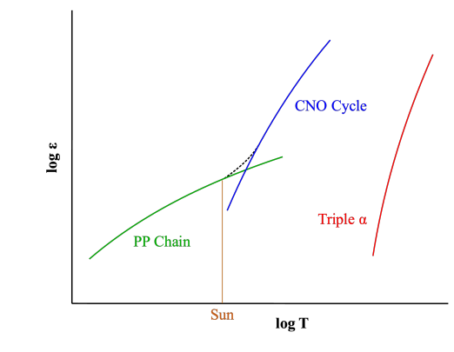
Energy distribution in stars.
Up until and including iron, fusion gives energy. After that, it will cost energy. That is why iron is generally the heaviest abundant element found. Heavier elements do exist by capturing neutrons via either the s-process or the r-process. Using beta-decay, heavier elements get produced. The rapid process only occurs in supernova type 2 or neutron stars merging.
Supernova 1a can also form heavier elements. This is when a white dwarf accretes mass and collapses onto itself.
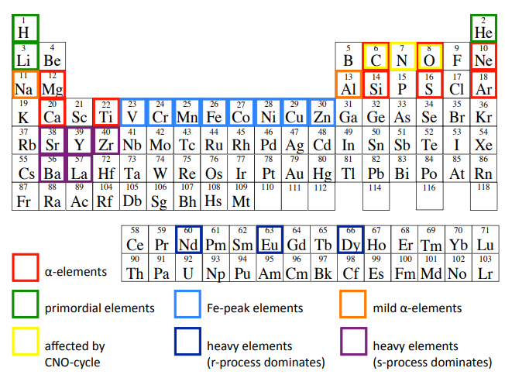
- Derive the formulas for the metallicity evolution as well as the corresponding fraction of stars at a certain metallicity interval in a closed box model
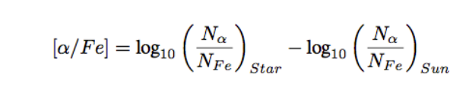
These are the general formulas for metallicity.
For the derivations of the formulas in the closed box model, see slides lecture 9
- Discuss the assumptions of a closed box model and their caveats
The closed box model is a very oversimplified model of enrichment in a system. It is based on a couple of assumptions:
  - Isolated system -> Mass conservation
  - Well mixed gas
  - Initial state has no metals
  - Stars immediately die, returning their metals to the gas
- Describe the broad distribution of galaxies and their galaxy types within the Local Group
Our local group is very average. It is about 1Mpc in radius and contains just a handful of galaxies, and a couple of irregulars. There are also quite a bit of dwarf galaxies. A lot were found using SDSS.
[TODO this might be a bit incomplete]
- Explain how a different alpha-element to iron ratio can arise in different galaxies
This is due to their age and the chemical composition upon formation. Supernovae type 2 happen way earlier than type 1a, which gives different metals to the gas. This gives a different alpha to iron ratio.
- Describe the main properties of disk galaxies in photometry
The disk consists of a bulge, spiral arms, possibly a bar and a ring. There is also a lot of non-transparent dust in the galaxy. This dust will seem dimmer when seen edge on compared to face-on. For a dusty galaxy, the surface brightness is independent of inclination.
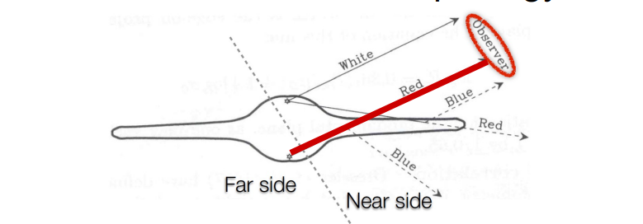
Light from the far side has to travel through the dust, making the light appear more red. Light scattered from the bulge onto the arms will appear more blue, as blue light has a higher tendency to scatter.
The light can be scattered using ellipses, this is similar to isophotes? This is dependent on the bandpass, as the inner disks will appear redder than the outer disks. This is mostly due to the age of the stars (and the amount of dust?)
- Describe the properties of the bulge components
Many galaxies have a bulge, where there are a lot more and older stars. They can have different shapes: round, flattened, ellipsoidal and bar like. The Sersic profile can be used to map the bulge.
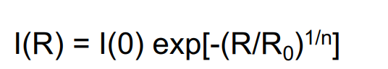
N will range from 1 to 4 typically, 4 being called a deVaucouleurs profile, which is also used for ellipticals.
- Discuss various scenarios on the origin of spiral arms
The spiral structure is visible in all bands. In redder bands it is less visible and way smoother, but its still there. The first idea on the origin of these arms is that they are due to the rotation of the galaxy, but this would make them too tightly wound. The density wave model states that there are more dense regions in the disk, which have a larger gravitational attraction, meaning that more dust piles up and stars are formed. Think of the traffic jam analogy.
- Explain why HI observations of spiral galaxies present dark matter evidence
Observing HI in an external galaxy is difficult and highly dependent on inclination. Mapping contours of the rotational velocity, one can get a better idea. These magnitudes depend on the mass and not the luminosity. The latter is observable. From this, we can derive the mass. But this supplies evidence that at least 50% of the mass must be dark and not luminous for all the disk galaxies.
- Describe and use the Tully-Fisher relation
For high inclination, the peak rotation speed can still be obtained using the Tully-Fisher relation. This is done using the emission as a function of the line of sight [TODO idk whats meant by this]
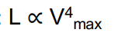
Note that this is not exactly the same between different bands. It is more tight towards the red end of the spectrum. Blue luminosity fluctuates more.
- List the three main classes of elliptical galaxies and describe their general properties
The properties of an elliptical galaxy depend mostly on its mass. We can divide them into three classes: giant elliptical, intermediate, and dwarf ellipticals. These are subdivided based on its luminosity. Using the Sersic profile with n=4, one can map giant and intermediates. For dwarf ellipticals, n=1 is used.
- Describe triaxial, prolate and oblate shapes and how isophotes of systems with these shapes look when observed at an inclination angle
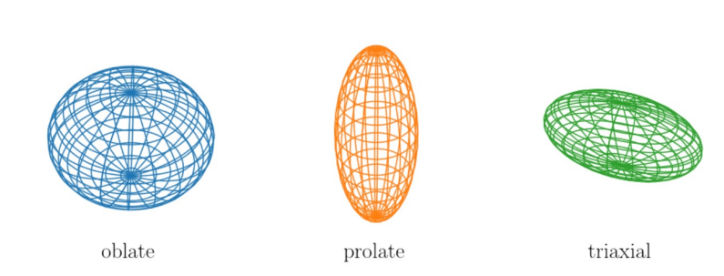
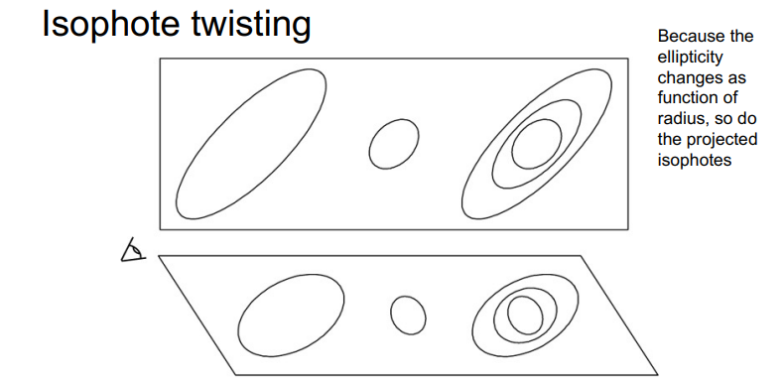
- Explain how we measure radial velocities and velocity dispersions
By taking spectra and taking the redshift from the absorption lines. From the amount of doppler shift, the radial velocity can be found.
For a more in depth explanation, see lecture 11
- Explain a general framework for the creation of elliptical galaxies and the differences between the various classes
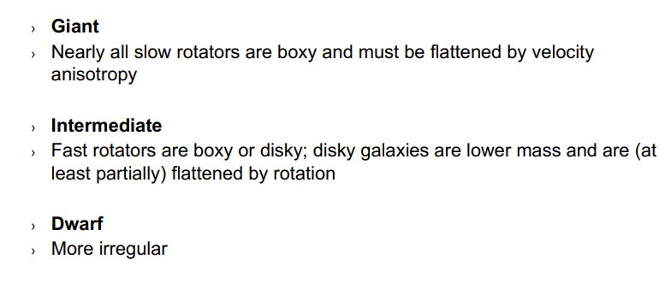
- Describe the Faber-Jackson relation and the fundamental plane
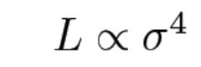
Distances from here aren’t very accurate.
[TODO fundamental plane, what on gods green earth is even that?]

